
OFFICE OF RESEARCH
Bridge Funding Program

APPLICATION COVER PAGE
Application Routing Instructions
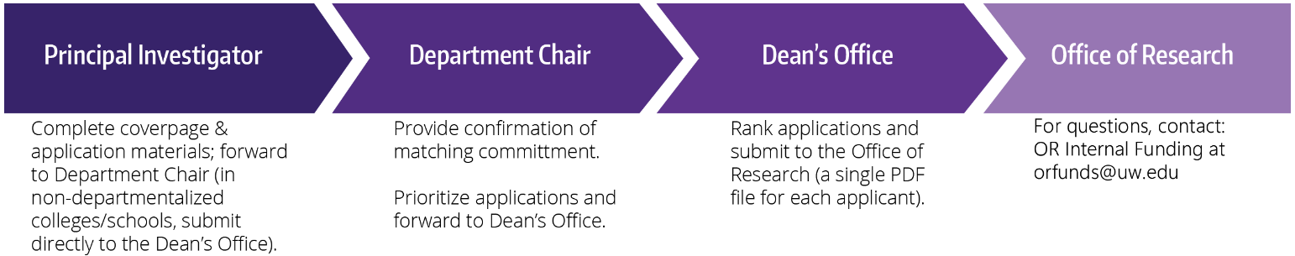

Principal Investigator Information
Name: Last, First, MI |  | Title: Choose title If other, please specify here.
Email: Click here to enter text.
School/College: Choose an item. If other, please specify here.
Department/Division: Click here to enter text.
Department Chair: Name and email in this format: Last name, first name <email>.

Admin/Grant Contact: Name and email in this format: Last name, first name <email>.

Budget
Provost Amount Request:
Matching Amount Request:
Total Bridge Fund Request:
Eligibility Statement
Select which eligibility statement that best applies to you:
☐ I will not have more than $30,000 funding from any source for carrying out research in my laboratory (either as PI or as a co-investigator on another PI's grant) by 6 months after the due date for this application.
☐ I will not have funding for more than 50% of my salary from any source by 6 months after the due date for this application.

If neither statement applies to you but after reading the eligibility FAQs you believe you are eligible, please contact Office of Research Internal Funding Program (orfunds@uw.edu) to request a waiver.

Did you also apply for Royal Research Fund (RRF)? ☐Yes ☐No

Applicants who apply to both the RRF and Bridge programs simultaneously will be eligible for only one award.

