 |  | GUIDANCE Pre-Review

Table of Contents
- Purpose
- Context
- Review Strategy Principles
- Review Tracking System
- Letter Writing Guidelines
- HSD Letter Style Guide
- Related Materials
- References
- Version History
- Appendix A: Example Review Tracking Systems
- Appendix B: Needs Improvement Screening Letter
- Appendix C: Improved Screening Letter and Follow-Up Letter

- PURPOSE [top]
This document provides guidance for Human Subjects Division (HSD) internal review staff conducting pre-review of applications. The tools in this guidance assist staff in conducting a pre-review process that is in line with its purpose, as is outlined in the SOP Pre-Review.

- CONTEXT [top]
The GUIDANCE Pre-Review should be used in tandem with the SOP Pre-Review and WORKSHEETs Pre-Review to aid HSD staff in identifying screening points, keeping track of screening questions and determinations, and turning screening points into well-organized and effective correspondence.

- REVIEW STRATEGY PRINCIPLES [top]

These over-arching principles set parameters for HSD staff when conducting pre-review and IRB review that align with the HSD strategic goals. Using these principles will streamline the pre-review process by helping to ensure that reviews are consistent, efficient, reasonable, and within the bounds of HSD and IRB purview.
Principle 1: Review to the applicable regulations, including the Criteria for Approval, and HSD/UW policy but not beyond.
- Do not request changes or place restrictions if the research meets the Criteria for Approval without changes or restrictions.
- Ask questions or for clarification only when you understand the regulatory or policy basis for doing so and when additional information is needed based on the regulations or policy.
- Each application should be weighed against the regulatory and policy requirements specific to that application and independent of any previous review.
Principle 2: Make sure you understand the study design and procedures before you request changes or place restrictions. Ask the researchers to provide more information if you don’t understand the design, methods, science, etc. This can include requests for less conventional information such as pictures of a device or a flow chart for the study design.
Principle 3: Consider the rungs of the “Regulatory Ladder”, in the correct order, to determine whether the application qualifies for a determination or whether it requires expedited or convened IRB review.
Principle 4: Use a tiered approach to corresponding with the researcher, first making sure you understand the study design and procedures, and the appropriate level of review before requesting changes to the application.
- Example: You may not need to require extensive revisions to the IRB Protocol if a study qualifies for a determination.
- Example: Consent form revisions should generally not be requested until the IRB Protocol and other study documents have been edited for accuracy and consistency.
Principle 5: Calibrate the level of review to the level of risk. Lower risk research does not require the same level of protections to meet the Criteria for Approval.
Principle 6: Embrace flexibility in study design when the flexibility is allowable under the Criteria for Approval. The lower the risk, the more room there is for flexibility.
Principle 7: Take responsibility for regulatory determinations because we are the regulatory experts.
- When you are the Designated Reviewer use the first person in your correspondence, don’t hide behind the “Subcommittee”.
Principle 8: Communicate with researchers in a clear, concise manner using an approachable, personable tone, while providing a helpful level of explanation.
Principle 9: HSD uses the acronym P.A.U.S.E as a framework to interrupt self- identified bias while reviewing applications. Don’t forget to- P: Pay attention to your reactions A: Acknowledge your assumptions U: Understand your perspective S: Seek different perspectives E: Examine your options and make a decision.

- REVIEW TRACKING SYSTEM [top]

This model provides a framework for HSD staff to read through applications and keep track of the many considerations related to conducting a thorough and complete review.

There are many correct ways to identify and track review considerations so long as the method you use results in a thorough and complete review. The model presented below is one suggested method and you may use it in whole or in part depending on what works for you. Once you decide on your method, use it with every review to increase consistency and efficiency. For determinations and other simple reviews, you may only need to use certain elements of your chosen method.

Step 1: Activities preparatory to pre-review.

Create a “Notes” document for the application and save it to a folder specific for the review of that application. (See APPENDIX A for examples of Notes documents and review folders.)

The Notes document:
- Tracks regulatory oversight, waivers, populations, other regulatory determinations; may contain a study summary; lists your questions about the application; identifies areas where you may need to obtain a consultation; is a place to record information for the Pre-Review Memo for full board studies; and should include any other information that is helpful for your review.
  - Is detailed enough that if a researcher responds several weeks or even months after you send a pre-review letter, you can quickly reorient yourself to the application and identify next steps without having to review all the materials again.
  - May include a copy of the “modification summary” information from Zipline which limits the number of places you need to reference during your pre-review and also allows you to “check off” items in the summary.
  - Is a “living” document that is updated with receipt of each pre-review letter response so that it always reflects the current state of your pre-review process.

Step 2: Start with the Big Picture.
- Begin your review by reading the SmartForms to obtain a broad overview of the study (i.e. regulatory oversight, funding, engagement).
- Keep this overall view in mind and carefully consider the “Regulatory Ladder” as you begin reading the application materials and before diving too deeply into composing correspondence.
- Use the appropriate WORKSHEET Pre-Review to guide your review and identify the applicable regulatory and policy requirements.

Step 3: Get into the details.
- As you make your way through a careful read of the IRB Protocol and other application materials, continuously update your Notes document with observations about the study that you want to keep track of and come back to and rough notes about questions you have that may eventually become letter points. Many of your questions will be answered as you continue to read and analyze.
- You may want to save study documents in the review folder (e.g., IRB Protocol, consent form, focus group guide) in which you can make comments.
- Ideas for keeping track of responses with multiple rounds of pre-review letters.
  - Organize the folder and Notes document in a way that allows you to check off items the researchers have completed and to keep track of what still needs to be addressed. One efficient method is to use the “strike through” action in the pre-review letter response or your Notes document when researchers have completed a request and to use highlighting or a comment to indicate where additional action is needed.
  - If you need to use a tiered correspondence approach you can keep track of questions you may need to ask with a subsequent letter in the Notes document.
  - Make use of subfolders
    - Move documents into a “completed” subfolder to indicate that the required revisions have been made.
    - Create subfolders for “pre-review letter 1”, “pre-review letter 2”, etc. along with their respectively revised documents.
  - Use the “compare” function in Word to verify all revisions were completed using tracked changes or to identify only the revisions that occurred since the last letter you sent.

- LETTER WRITING GUIDELINES [top]

These guidelines assist HSD staff with using information gathered according to the Review Strategy Principles and Review Tracking System to write screening points to send to the researcher.
Guideline 1: Researchers should understand what you’re asking, why you’re asking it, and how to give you what you’re asking for.
- Find a balance between clearly stating the question or request and allowing for flexibility in the response. The ultimate goal is for researchers to accurately and clearly describe their research protocol.
- If your review point is based on an assumption, clearly spell out the assumption.
Guideline 2: Start with draft letter points rather than trying to edit and perfect letter points while reading through the application.
- It is likely you will remove or heavily edit some of the draft letter points after you’ve read through all the materials.
Guideline 3: If you’re having a hard time writing the letter, call the researcher.
- If you don’t understand the study design or procedures or you find there are too many “if/then” dependents while you’re drafting the letter, a quick call to the researcher is likely to increase your understanding so that you can proceed with the letter.
- The resulting letter points should include a summary of the phone discussion along with the associated request for revision.
Guideline 4: Keep your audience in mind when writing the letter.
- Researchers new to Zipline or that have struggled in the past may benefit from step-by-step instructions in the correspondence about how to respond in Zipline, while seasoned researchers may only need the general reference to Zipline instructions embedded in the letter template.
- Be clear about where you are in the review process. If there are likely to be multiple rounds of pre-review letters, let the researcher know.

Guideline 5: Be mindful of tone.
- Don't write when you’re angry, annoyed, or otherwise not in the right mindset.
- Find balance between polite and to-the-point. “A helpful amount of information” does not mean more or all the information.
- How many times should you write “please” in a letter? You can be strategic about this and use it once, at the top of the letter. It may be appropriate to use a few more throughout the letter but every letter point should not start with “please”.
Guideline 6: Use judgement to decide whether to send questions and requests in the text box of the Request Pre-Review Clarification activity or as an attached pre-review letter.
- A pre-review letter is more appropriate than a text box clarification when: there are more than just a few questions and requests, and/or answers are likely to be long or detailed (as opposed to a short factual response).
- Regardless of the method you use, all review correspondence must be in Zipline. It will be very rare that review-related correspondence occurs outside the system. On those rare occasions, all email or other non-Zipline correspondence must be uploaded to the application.
Guideline 7: Use judgement when deciding whether to require edits to the IRB Protocol, supplements or other documents.
- Requiring edits is most appropriate when: the application requires IRB review, and any of the following are true: the response is a correction of a factual error or the supplying of information that was inappropriately omitted in the IRB Protocol; the study is likely to last a long time; the study is likely to involve many modifications.
- For determinations, it is often sufficient to obtain clarification about the study by way of correspondence rather than requiring updates to study documents unless the determination is likely to involve many modifications or there is some other reason to require updates to the application materials.
Guideline 8: Editing letters involves much more than just spell check and should include:
- Thought, analysis, organization.
- Decisions about whether to combine or split questions.
- Verification that all questions are tied to Review Strategy and regulation.
- Avoidance of ambiguity; a clear request is more likely to solicit a clear response.
- Understanding that not all points from the draft letter may make the final cut.
Guideline 9: Read the edited letter at least once before sending.
Guideline 10: Be open to feedback from your supervisor by accepting guidance and taking part in respectful discussions when you’re unsure why edits are being requested.
- Keep in mind that your supervisor has the final say about letter edits.
Guideline 11: Verify before sending the clarification request that you have attached the correct letter.

- HSD LETTER STYLE GUIDE [top]

The style guide assists HSD staff with ensuring written correspondence is clear, concise, and polite and that it elicits the desired information from the researchers. Some of the content in the Style Guide is adapted from the University of Washington Professional & Organizational Development Course: Writing for Readability.

Use Plain Talk
- Use short, focused sentences.
- Begin with the main message and say what needs to be said, then say no more.
- Avoid repetition. We tend to repeat ourselves when we don’t know what we’re talking about, are afraid to give bad news, and when we need to apologize or say thank you.
- Choose words the reader uses. Be mindful of over-using regulatory references with researchers.
- Rip out redundancy.
- Write in active voice.

Organize effectively. Create headings and order the letter points in a way that reflect a logical flow.
- Review the TEMPLATE Pre-Review Letter for common headings
- Order the letter points in the same sequence that the researcher will encounter them in the referenced document (i.e. Letter points in reference to the IRB Protocol should be asked in the same order as they appear in the form).

Make use of lists and formatting to improve clarity.
- Use numbers and letters rather than bullets for ease of reference.
- Formatting (e.g., bold, underline, italics) can be used to draw attention to particular points.
- Multiple questions in one point may be better communicated with sub-points for ease of identifying questions you want answers to.

Use a three-part question structure.

This reinforces the reviewer’s understanding of the situation and increases the likelihood that researchers will understand what you’re asking, why you’re asking it, and how to give you what you’re asking for.
- Cite the application: “In section 4.7 of the IRB Protocol you indicate that participants will be asked to sign the consent form.”
- Present the problem: “This question refers to consent for recruitment and screening rather than consent to participate in the main study and it is my understanding that there is no consent process for recruitment and screening.”
- Propose a solution: “If my understanding is correct, delete the reference to a consent process in 4.7. Main study consent is already described in section 8 of the IRB Protocol.”

- RELATED MATERIALS [top]
- CHECKLIST Regulatory
- SOP Pre-Review
- TEMPLATE Pre-Review Letter
- WORKSHEET Pre-Review, Continuing Review
- WORKSHEET Pre-Review, Initial Application
- WORKSHEET Pre-Review, Modification

- REFERENCES [top]
University of Washington, Professional & Organizational Development, “Writing for Readability”. Jordan Peabody – Peabody Communications. 2018
- VERSION HISTORY
Version Number | Posted Date | Implementation Date | Summary of Changes
1.1 | 06.25.2024 | 06.25.2024 | Revise reference to CHECKLIST Regulatory; add reference to P.A.U.S.E. Framework
1.0 | 01.03.2020 | 01.03.2020 | New guidance

Keywords: Pre-review

- APPENDIX A: EXAMPLE REVIEW TRACKING SYSTEMS [top]

This appendix contains two examples of how you might structure your Notes document and the associated review folder.

EXAMPLE 1 – An expedited study that has undergone 1 round of screening and the reviewer is taking notes to prepare for a second round.

The Regulatory Considerations section was recorded as the reviewer read through the application and identified these issues. It is placed at the top of the document for quick reference when it comes time to complete regulatory documentation by filling out the Regulatory Checklist and completing staff data entry.

The Aims are included to help the reviewer quickly remember what this study is generally about.

During Screen 1, the reviewer makes note of issues to verify across application materials and records rough drafts of letter points. When the response is received, the reviewer uses the ‘strike-through’ action to mark that it has been completed. The highlighted item under Screen 1 was not completed by the respondent and you’ll see that it is repeated under the Screen 2 heading.

The notes under Screen 2 have the reviewer ready to draft the second screening letter. The reviewer took notes about some issues the reviewer wanted to verify related to the consent forms. Those issues resolved by reading the application and so the reviewer used ‘strike-out’ for those points. The remaining points will be refined in the second letter.

The Example 1 review folder below demonstrates the reviewer’s use of subfolders to separate documents by type and round of screening.
Johnson, %1234, initial
Regulatory Considerations
No fed $ now but likely to get some later
$ not routing through OSP
Exped cats 4, 5, 6, 7
Children and prisoners included in aims 3 & 4 records reviews – (prisoners are data only and no fed $ so no cert; advise with NIH $ will need to certify)
Waive consent for Aim 1 and Aim 2a eligibility screening
Waive consent, permission, assent (404 risk/benefit) for Aims 3 & 4 records access
CfA for Prisoners aims 3 & 4 records access
Waive doc for aims 1, 2a/b (even though they haven’t asked for it).

Aims
- Validate SHOEBOX audiometer and ECGs in 200 patients relative to traditional methods
- Patient (a) and provider (b) FGs about use of alternative testing and videoconference experience
- Records review pre/post use of alternative methods (will include children and data will note if prisoner)
- SAIA of DR TB care cascade with lab, clinic, M&E data (will include children and data will note if prisoner)

Screen 2
Delete Portuguese docs from Supp Docs
Are Aim 2b provider procedures FGs or IDIs? Harmonize CF and IRB P.
Researchers verified they want to replace “survey” with “study” in recruit materials but recruit script changes weren’t made.
Payment is travel reimbursement ($1-$20 USD) or food ($5-$10 USD)
Verify IRB P 5.1 match CFs
Verify 8.2b/8.2c matches CFs
IRB P 5.10 describes obtaining consent for future use/banking of data/specs; also describe consent to withdraw – need to describe this out in more detail in CF
Return of Results supp states that subjects’ doctors may be informed about potential serious medical diagnoses and also mention that results will be returned to subjects even if not serous med diagnosis – add to CF

Screen 1
Study Scope 5 (change to ‘yes’ because evaluating safety/efficacy of devices); fill out Devices smartform
CFs and recruit scripts reference “survey” in the place where we would write study – verify this is a translation issue and that “survey” doesn’t mean an instrument like it does in the US
CFs and 5.1 note that identifier links will be destroyed at end of study or by 2024. Revise to say “at the end of the study and per records retention requirements.”
Aim 1 and 5.1 describe the two types of tests and how the novel tests differ from experience of gold standard tests (what is subject experience?)
5.14 if want to link databases not already described, will need to submit a mod to add them to the application (and so we can grant requisite waivers)
9.6a need to choose data security level (can list exceptions – such as needing to keep data directly identifiable until linkage is complete- in b)
10.1 Aim 1 CF describes a risk of learning a diagnosis – add this (and probability/risk mitigation strategy)
10.1 note do not expect significant risk of using devices, but what are non-significant risks (probability/mitigation)?
5.1 references study flow sheet and work plan but this is not uploaded
5.1 references appendix with FG topics – not uploaded
5.3 Aim 2 data source listed as routine weekly evals (what is this data?)

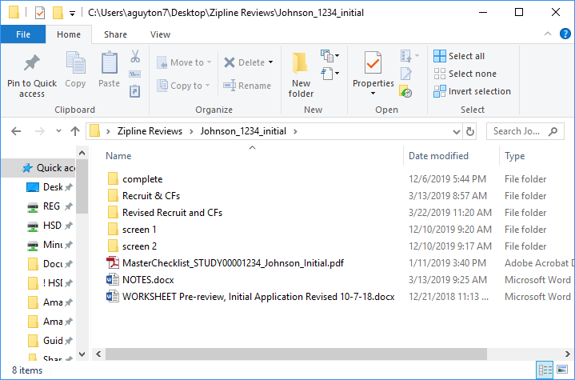

EXAMPLE 2 – A full board EFIC study that was deferred twice is now ready to conditionally approve.

The Notes document includes screening requests for the researcher as well as notes about what to include in the Pre-Review Memo for the Board.

The Example 2 review folder below does not use subfolders. Instead, files have been named for ease of identification. Researcher responses have the same file name as the original correspondence but with “RESPONSE” on the end. Correspondence of the same type are named in sequential order (e.g., Screening 1; Screening 2).
Pre-Review Memo

- FDA-regulated: IDE, SR device
- WoC/WoH/CA for screening records.
- Need RSC approval.
- DSMB ok?
- Data security OK? Some data being stored w/ identifiers (p. 15)
- See screening 1 letter responses for highlights for PRN.
- P. 8 of clinical protocol: 7 patients so far
- CF stuff:
  - Use UW template?
  - Ct.gov lx req’d.
  - HSAP lx
  - Unknown risks (10.3): the limited experience of the Basilica method with TAVR
  - 10.7: w/drawal w/o consent
- Need to update FCOI questions in SmartForm and 13.3 in IRB Protocol.

Questions for researcher:

- Upload funding proposal to ‘Funding Sources’ SmartForm in Zipline.
- IRB Protocol:
  - Only the Haptoglobin lab test is carried out specifically for research: all other procedures are for SoC?
  - CT contrast = study-dictated? Click ‘Yes’ on drugs supplement, list all study-dictated drugs, upload ‘drugs’ supplement.
- IDE letter in ‘Devices’ SmartForm is for ASAHI Astato XS 20 Peripheral Guide Wire only. Upload IDE letter for SAPIEN 3 Transcatheter Heart Valve.
- Need RSC approval: upload approval to ‘Supporting Documents’ SmartForm.
- UW is Network coordinating center or hub for the UW site per p. 2 of multi-site supplement: described in Protocol? Do we get identifiers or anything? Add to sections 5.1, 5.5.
- NHLBI will have access to UW identifiable data/specimens (3.2 in multi-site supplement): data security (UW, transit, NHLBI) described in Protocol?
- Answer question #8 in Device supplement.

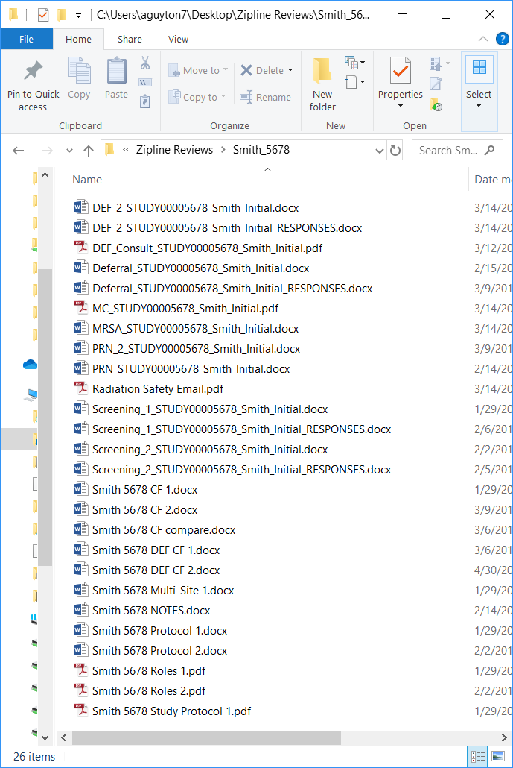
- APPENDIX B: NEEDS IMPROVEMENT SCREENING LETTER [top]

This is a minimal risk pre-review letter containing many inconsistencies with this Guidance.

The headings and order in which questions appear are not in a logical flow. The numbering system is not consistent, nor is the way in which the questions are structured. The respondent will have to jump around the application materials and it’s not always clear where in the materials the issue occurs.

Most of these questions could be improved by re-writing them in the 3 part structure which would ensure the reviewer and respondent both understand what is being asked, why it’s being asked, and how to provide the requested information or revisions.

There are several instances where a failure to use a tiered screening approach has cascading negative effects throughout the letter.
REQUEST FOR ADDITIONAL INFORMATION

January 3, 2020

Re: Zipline #00004321, “Minimal Risk Intervention Study”, Initial Application

Dear Dr. Thompson,

The Subcommittee has reviewed your application and found that additional information or documentation is needed in order for your application to move forward in the review process.

- After reading through the IRB Protocol, Study Protocol, and grant application, it is unclear to the Subcommittee whether the A1c point-of-care testing is being done for regular clinical care or strictly for research purposes. Does the A1c testing happen in the clinic? Is the A1c testing administered by clinic staff or research staff? Are the clinic staff acting as members of the research team to administer the test? If the test is only for clinical care purposes, will the research team then extract the testing results from the medical record? Please refer to GUIDANCE: Is it Research? to help you make the decision.
- In the phone script you indicate that you will administer a screening questionnaire. Upload this questionnaire to Zipline.
Missing Subject Group
- In question 2.2 you have not described the patients whose records you will obtain without consent. Please describe those subjects here.
- In questions 5.4-5.7 you have not described the patients whose records you will obtain without consent. Describe those subjects here.
- In question 8.2 you have not described the patients whose records you will obtain without consent. Describe those subjects here.
Inconsistencies
- Identifiers: In 5.5b you note that MRN and other direct identifiers will be stored directly with study data in order to continually link back to medical records during the course of subjects’ participation. In 9.6b you mention that a unique study identifier will allow study data to be indirectly linked to identifiers. If 5.5b is correct and the data are directly linked to identifiers, then update 9.6b to match. If 9.6b is correct and the data are indirectly linked to identifiers, then update 5.5b to match. If there is some mix of the two, make that clear in both questions. Be sure to also update 5.5c to match.
Other IRB Protocol Changes
- The Study Protocol has more information about the study procedures than the IRB Protocol. Provide more details about your procedures in the IRB Protocol.
- Section 5.1
- If you determined that the A1c testing is for research purposes, add a description of this procedure. If it is not for research, then don’t add anything here.
- Your application states that you will enroll subjects aged 16-40. 45CFR46.402(a) defines children as, ‘persons who have not attained the legal age for consent to treatments or procedures involved in the research, under the applicable law of the jurisdiction in which research will be conducted.’ There are several Washington State laws (RCWs) that allow a minor to consent as an adult for research purposes but none of those RCWs apply to these types of procedures. Therefore, the Subcommittee has determined that the 16 and 17 year old subjects are minors for the purposes of the research and you will need to fill out the application to include children.
- 9.6: Level 1 data security protections are not high enough for this study. Please review the Guidance and choose a higher level.
- 10.1: If you have determined that the A1c testing is not research, remove the description of risks from section 10. If you have determined A1c is for research, then leave these risks here.
Consent Form
- Since this research involves children you will need to upload assent and parental permission forms. The consent form you uploaded could also be used as the assent/permission form. If you opt for this route, add a brief statement to the beginning of the consent form explaining that the form is used to consent adults subjects and to obtain assent and parental permission from minor subjects. This statement should also note for parents providing permission that the form is written from the perspective of their child who is the subject. You could also add an assent/permission from which should have the same statement letting parents know that the form is written from the perspective of the child who is the subject. Alternatively you could upload a separate assent form and a separate parental permission form so that you would have 3 separate documents.
- In section 5.12 of the IRB Protocol you note that subjects may be contacted about future research studies. Add a statement informing subjects about this in the consent form. If you are making a parental permission form or a permission/assent form, please add the statement there too. If you have a stand-alone assent form you can add the statement if you wish but the regulations do not require assent forms to have all the same elements as consent and permission forms.
- Insert this information into the “Subject’s Statement, “If I have questions about my rights as a research subject, I can call the Human Subjects Division at (206) 543-0098 or call collect at (206) 221-5940.”
- In ‘Confidentiality of Research Information’ the consent/assent/permission form states, “The link between the data and your identifiable information will be destroyed 1 year after study completion.” Please note that this may conflict with records retention policies which require you to retain most research data for at least 6 years after completion of the study. Revise the wording in the form to something less specific, (e.g., “The link between the data and your identifiable information will be destroyed after completion of the study and according to records retention requirements.”).
Please feel free to contact me with questions. I look forward to receiving your response.
Kind regards,
Jane Smith
Review Administrator, IRB X
(206) 543-0098, janesmith@uw.edu

- APPENDIX C: IMPROVED SCREENING LETTER AND FOLLOW-UP LETTER [top]

Improved Screening Letter

This is the letter from Appendix B re-written to be in line with the principles and guidelines in this document.

This letter demonstrates effective organization by using headings to direct the respondent to the section of the Zipline application in question and ordering the questions to match the order in which they will be encountered in the application. Questions with multiple requests often include sub-points to make it easy for the respondent to identify the items that need action.

The 3-point question structure is utilized throughout the letter so that the respondent can quickly identify what is being asked of them, why it’s being asked, and how to give the reviewer what they’re asking for.
REQUEST FOR ADDITIONAL INFORMATION

January 3, 2020

Re: Zipline #00004321, “Minimal Risk Intervention Study”, Initial Application

Dear Dr. Thompson,

Thank you for submitting your application to the Human Subjects Division. Additional information or documentation is needed in order for your application to move forward in the review process.

General
- Thank you for taking the time to speak with me on the phone to clarify my understanding of your study procedures. During that phone call you confirmed that the point-of-care A1c testing is approved for clinical use and that it is administered as part of the subjects’ clinical care. You will obtain test results from the medical record but the use of the device itself is not a research procedure. This letter point is here to summarize our conversation; there is no need to respond.
Zipline SmartForms
- Supporting Documents: In the phone script you indicate that you will administer a screening questionnaire to determine subject eligibility but I don’t see the questionnaire uploaded or described anywhere else. Please either:
  - Upload the questionnaire to the Supporting Documents SmartForm; or
  - Describe the range and scope of the content of the questionnaire in 4.6 of the IRB Protocol.
IRB Protocol:
- On page 30 of the Study Protocol you describe a process by which you will obtain A1c testing data from patients who were admitted during the recruitment period but who were not included as study subjects. These subjects are not described in the IRB Protocol.
- If you plan to obtain this data, update the following sections of the IRB Protocol to describe these subjects: 2.2; 5.4-5.7; 8.2 (change answer to ‘yes’ and add this subject group to the table).
- If you will not obtain this data, confirm that is the case.
- 5.1: On page 8 of the Study Protocol under Study methods you describe some of the procedures in greater detail than in the IRB Protocol. To 5.1 in the IRB Protocol add details from the Study Protocol about: a) how procedures differ between intervention and control groups; and b) the procedure for DBS collection and storage.
- 5.5 & 9.6b: In 5.5b you note that MRN and other direct identifiers will be stored directly with study data in order to continually link back to medical records during the course of subjects’ participation. In 9.6b you mention that a unique study identifier will allow study data to be indirectly linked to identifiers. Please revise 5.6b, 5.6c, and 9.6b so it is clear which data is directly associated with direct identifiers and which study data will be associated only with the study code.
- Sections 6 & 7: Your application states that you will enroll subjects aged 16-40. In Washington State individuals under the age of 18 are considered minors for the purposes of this research. Please complete sections 6 & 7 of the IRB Protocol to describe your plan for obtaining assent and parental permission for 16 & 17 year old subjects.
  - Note: Given the age of your subjects and the study design, the consent form you have submitted is likely to be appropriate to also serve as the assent and parental permission form for these minor subjects. Alternatively, you may submit a separate Assent/Permission Form to be used with the 16 & 17 year old subjects you enroll.
- 9.6: Level 1 data security protections are not appropriate for this study since you will be obtaining personal health information from the medical records in addition to other data for your study. Please review the ZIPLINE GUIDANCE: Data and Security Protections. Level 3 (could cause risk of material harm to individuals if disclosed) or above would be most appropriate for your study. I’m happy to talk with you about how to use the Guidance by phone or email if you like.
- 10.1: You have listed the risks of the finger stick for the point-of-care A1c testing but, as noted at the top of this letter, you have confirmed that the A1c testing is not being conducted for research purposes. Please delete all references to A1c testing risks in this section.
Please feel free to contact me with questions. I look forward to receiving your response.
Kind regards,
Jane Smith
Review Administrator, IRB X
(206) 543-0098, janesmith@uw.edu

Follow Up Screening Letter
This is the letter that the reviewer would send after reviewing the response to the “Improved Screening Letter”. Notice that the reviewer had some additional consent form revisions that were not mentioned in the first letter. These revisions were saved on the Notes document until all other issues were cleared up so that the respondent would likely only have to make one round of consent form edits.
REQUEST FOR ADDITIONAL INFORMATION

January 10, 2019

Re: Zipline #00004321, “Minimal Risk Intervention Study”, Initial Application

Dear Dr. Thompson,

Thank you for your response to my last screening letter. Please respond to a few additional requests in the letter points below.

- In your response to my first screening letter you confirmed that you will use one form for consent, assent, and parental permission.
  - Please add a brief statement to the beginning of the form explaining that a single form will be used to consent adult subjects and to obtain assent from and parental permission for minor subjects. This statement should also note for parents providing permission that the form is written from the perspective of their child who is the subject.
- In section 5.12 of the IRB Protocol you note that subjects may be contacted about future research studies. Add a statement informing subjects about this in the consent/assent/permission form.
- Insert this information into the “Subject’s Statement, “If I have questions about my rights as a research subject, I can call the Human Subjects Division at (206) 543-0098 or call collect at (206) 221-5940.”
- In ‘Confidentiality of Research Information’ the consent/assent/permission form states, “The link between the data and your identifiable information will be destroyed 1 year after study completion.” Please note that this may conflict with records retention policies which require you to retain most research data for at least 6 years after completion of the study. Revise the wording in the form to something less specific, (e.g., “The link between the data and your identifiable information will be destroyed after completion of the study and according to records retention requirements.”).

